

Buying Guide Series | Telephony / Voice
This Buying Guide developed by Phil Clark provides CIPS members with a checklist of questions to ask in order to create a requirements specification for buying voice or telephony related solutions (Technical, Operational and Commercial), as well as a series of questions to ask that validate a supplier’s proposals. It also provides you with suggestions on how to review the supply market to source the most suitable supplier of services for your business requirements.

Title
Description



This knowledge paper is supportive of Procurement professionals
operating at operational of the CIPS Global Standard
CIPS members
can record
one CPD hour

Contents

Introduction

Understanding the Terminology

Major Industry Players

Developing Your Specification
  - Technical
  - Operational
  - Commercial
  - Sourcing process

Verifying the RFP/RFQ
  - Technical
  - Operational
  - Commercial
  - Other

Understanding the Market

Further Resources

Buying Telephony

Introduction

Telephony, or Voice, based services are the longest standing form of connectivity between offices and continue to be a core staple of every business. Convergence of Voice and Data services however is reducing the need for specific voice services, and similarly convergence of fixed telephony and mobile services are bringing further consolidation to a commoditised marketplace.

The focus for Voice services therefore has moved from the capacity and methods of connectivity and more to the functions or features of a voice solution. Basic services such as voicemail and call forwarding are commoditised, but more complex call centre or intelligent voice routing (IVR) solutions require more complex specialisms that can differentiate one service over another. Even more complex services, which interpret voice traffic into digital signals and allow for automation of call flows for inbound calls, or integrate call flows into core applications, require niche of specialist equipment that can be difficult or expensive to source.

Other market shifts, such as the migration from on-premise equipment to services delivered from the cloud, can drive significant cost differentials based on different approaches. Traditional telephony solutions are also being threatened by the “collaboration” suite of applications such as Microsoft Teams (Skype) or Zoom Video Conferencing (this is an enormous growth sector with hundreds of new entrants). Within this context, it is imperative that requirements are clearly specified, technology options are correctly assessed, and suppliers vetted for their credentials before selection.

Core voice connectivity is a commoditised service, but integration across voice and data, mobile and applications, demand complex sourcing and selection. Sourcing the right provider can be based on a number of specialist requirements, and these specialist requirements could make it difficult to find appropriate providers.

This Buying Guide developed by Phil Clark aims to provide CIPS members with a checklist of questions to ask in order to create a requirements specification for buying Telephony services (Technical, Operational and Commercial), as well as a series of questions to ask that validate a supplier’s proposals. It also provides you with suggestions on how to review the supply market to source the most suitable supplier of services for your business requirements.

Understanding the Terminology

Within the industry, much of the terminology is based on acronyms, some of which are defined as below:

- VoIP – Voice over IP – the method of transmitting Voice calls over a data connection, based on the Internet Protocol

- QoS – Quality of Service – the measurement of reliability of a connection, usually stated as “QoS guaranteed” to imply that the quality of a voice or video call will be

- Handset – the desktop device that some users prefer to make calls on because of the functionality it makes available

- Mobile App – an application that runs on a mobile phone that can replicate many of the features of a traditional phone handset

- PBX / Exchange – Private Branch Exchange, the central brains of a telephony solution that delivers most of the functionality required for a given company

- LCR – Least Cost Routing – a function that will allow for the redirection of calls based on the lowest cost service

- IVR – Intelligent Voice Routing – the “dial 1 for customer services” function that allows in bound calls route to their required destination

- ACD – Automatic Call Distributor – the function of automatically routing a call to a recipient, sometimes based on “which team/individual is less busy” or similar metrics

- POTS – Plain old telephone service

• DECT – Digital Enhanced Cordless Telecommunications (wireless handsets)

- CTI – Computer Telephony Integration – linking telephony to CRM applications or other services to record voice services on a computer

- CRM – Customer Relationship Management – software that stores information about customers for use in contacting them.

Major Industry Players

The major vendor players in the “Voice” market are merging with other categories to create more integrated solutions. Below is a list of some of the major players in the current market:

- Pureplay voice solutions: Avaya, Mitel, RingCentral, 8x8, Cisco, Gamma, BroadSoft (acquired by Cisco), Panasonic, 3CX, ShoreTel

- Collaboration / Unified Comms (integrated voice, video): Microsoft Skype For Business/Teams, Zoom, Cisco Webex, Google Voice

Developing Your Specification

The information you could provide in your specification can be split into three main areas, technical, operational, commercial and the sourcing process.

Technical

Location Requirements

Please complete the table below to describe the current office environment:
 | Post Code | Number and type of user | Data Connectivity at site (LAN) (include cabling type and quality for each site | Data Connectivity at site (WAN) | Voice Connectivity at site (PSTN/ISDN)
Location 1
Location 2
Data Centre 1.
Etc.

Feature / Function Requirements
 | Number of user / devices | Mandatory / Optional | Notes
Basic Desktop Phone
Voicemail
Call redirection / forwarding
Conference Calling |  |  | Worth stipulating both the number of users who need that function AND the likely maximum concurrent users.
Call logging
Call barring
Fax inbound / outbound
Call Transfer
Direct Dial In
Switchboard / Reception
Conference Rooms
Click to Call |  |  | Do you need to provide the ability to click from a desktop screen to dial a number?
Mobile to Fixed |  |  | How many people need to transfer calls from their mobile to a fixed phone (and back) whilst in a call?
Call Pick-up Groups |  |  | Do people need to be in a “pick-up” group which allows an inbound call to be answered by anyone in that group?

Note: This is ideally split by location. Mandatory vs optional is used to show the minimum / maximum capacities for each function to allow forward planning

Voice Integration

- Please outline any requirement, or preference, for integration with core applications for instance CRM systems

- Is there a need for a voice desktop / mobile application to use to dial out via PC/Laptop or Mobile device? (usually referred to as a softphone)

Call Centre Specific Requirements

- How many agents will be deployed within a Call Centre? How many calls are they likely to receive and what is the average call length? Where are these call centres located and what are their service hours?

- What are the peak and normal service hours for the call centre and how does the traffic / agents vary through this period? Are there seasonal changes to call centre traffic?

- What reporting do you need relating to Call Centre productivity / usage? Do you need to track calls handled per agent for instance?

- Is there any requirement for “Omnichannel” integration (e.g. Live Chat, WhatsApp / Messaging, SMS) with your voice services? (this can be quite a complex area and would be worth sourcing specialist procurement help).

Regulatory Requirements

Is there are requirement for any specific regulatory or compliance functions associated with voice applications, such as:
- Call recording and retention
- Payment Card detail recording / entry / security

Call Profiles

 | Estimated minutes per month | Notes
Intra-Office
Office-Company mobile
Office – Non-Company mobile
Office – National
Office – International
Inbound 08xx or 03xx
Is there are requirement for any specific regulatory or compliance functions associated with voice applications, such as:
- Call recording and retention
- Payment Card detail recording / entry / security

Operational

Site and Service Requirements
 | Service Hours | Criticality (H / M / L) | Resilience required | Dedicated or Shared building
Location 1
Location 2
Data Centre 1.
Etc.

Note: For “Dedicated or Shared building”, be clear as to how much effort will be required to organise access to the building to drop in new lines. For most Shared Offices (e.g. Regus), an understanding of the connectivity to the building via the Shared Office provider will need to be ascertained before a quote can be given

Resource Requirements

- Outline any internal resources you have to provide management, support or configuration of Voice circuits.

- Does anyone have any specific needs for equipment to support preferences or accessibility, for example:
  - Preferences for handsets or headsets (hands-free) to allow walking around the office?
  - Speech to text, or text to speech
  - Large screens or buttons

Billing Requirements

- How do you want the billing for calls / services to be presented, such that any internal cross charging or reporting can be achieved?

- Are there any requirements to implement caps / call barring on specific devices or generally

- VIP Users vs Normal users?

Known Changes / Strategy

- Are there any business changes that will need to be considered strategically as part of a new telephony installation?
- Significant increases or decreases in user population?
- Significant changes in locations / sites?
- Significant changes in business function (e.g. launch of a new call centre)?

Other Considerations

- Do you need new telephone numbers, or would you like to “port” any existing numbers to the new provider? If so, how many numbers would need to be transferred?

- How are you going to manage the project to migrate from current to new service provider, or are you expecting the provider to do it entirely (including managing your internal resources / other third parties)? Are there any good windows to achieve this when users are offline?

Commercial

- For each of your current providers, list provider name and contract end date (to confirm when new services can be sourced OR to confirm novation approach):
  - Existing calls and lines
  - Any existing voice equipment maintenance or support contracts (PBX)
  - Any existing licenses or contracts held with Video or Voice conferencing companies, or “free” services used by users already
  - Mobile contracts, including which network (e.g. Vodafone / O2) and when handsets expire

- Outline the term commitment you are willing to make to a new service

- Provide an overview of any Office365 or similar desktop licensing you have to allow people to assess the use of collaboration solutions such as Teams.

- Outline any preference for financial smoothing? Most providers will flatten the up-front cost of a new service over the term of the agreement if this is your preference, however, consider termination charges throughout the term in this regard.

- Are there any critical dates that the provider needs to consider (contract end dates, peak processing dates) when designing their migration plans?

- Is any current equipment fully written down / does it have a buy back value?

- Is there a budget set for the project and if so, how is it phased (all up front / capital expense OR operating expense)? What term are the costs budgeted for?

Sourcing Process

• What are the timelines that the supplier has for:
  - Reading and asking questions in the specification
  - Providing their written proposal
  - Coming in to present their proposal if appropriate
  - Receiving a decision on whether they have been awarded or not

• What are your time expectations for the project delivery?
  - Supplier commencement date after being awarded
  - Completion of transition project to new services

- What are your standard legal terms / principles for these services that the provider should adhere to?

Verifying the RFP/RFQ

When verifying the proposals there are a number of questions to consider and these can be split into technical, operational, commercial and other questions.

1. Technical

- What levels of capability does the supplier have regarding Office 365 and associated technologies (number of staff, partner levels/accreditations)? Do they have any specialist skills in some of the peripheral products (e.g. SharePoint, Exchange, Yammer, Teams)?

- How many other customers does the supplier have of a similar size and requirement to you, and are any of them referenceable?

- How will connectivity work to access cloud services (if appropriate) and how have they been sized to ensure performance isn’t an issue?

- What constraints are there with the technical solution in terms of future growth and performance? How will services be deployed (remotely, visit required, etc.)?

- For software based solutions, will patches and upgrades be provided by the provider as part of the service or chargeable, and if so on what frequency is this likely to happen (and at what cost?)

2. Operational

- What reporting / monitoring and management will the service come with? How will you be notified of a fault or potential fault?

- What are the expected turnaround times on a change / problem in terms of response and resolution? For cloud services, how quickly is expansion and contraction of services achieved? Who is running the “admin portal” and how quickly can license / configuration changes be performed?

- What are the hours of service, in terms of core hours and any extended support hours? Will support for the users be provided directly or is there an expectation that users will phone an internal “expert” before logging a call with the provider?

- What documentation will be provided as part of the service in terms of:
  - Design / architecture
  - Processes and procedures
  - Service user information (“How to” guides, etc.)

- Which parts of the service are provided by the supplier, and which are provided by other third party subcontractors (and who are they?)
- How will new future technologies be considered in terms of the service; will the provider suggest them proactively and how can they be incorporated into the services?
- How will other changes to the platform be communicated to the users / operations teams?
- Who will be the main contact points between you and the supplier:
  - Helpdesk touchpoints
  - Management / review touchpoints, and frequency / format
  - Executive level escalation touchpoints, and triggers

- Are the services regulated / certified to any ISO standards and if so, on what scope and when was the most recent audit?

- Does the provider have any examples of successful user adoption for recent implementations of a similar size and complexity to this one?

3. Commercial

- Are all prices fixed, or will they vary over time with usage / inflation / currency fluctuation? If so, how is this controlled through the contract?

- What is the expected payment profile (in advance, arrears / payment terms) and is a Direct Debit required? Does this fit with finance policy?

- If additional work is required, what is the day rate per skill set required, and will this be set in the contract at the outset?

- Will all services co-terminate or will there be different service end dates based on installation dates (more difficult to manage)?

- What are the termination rights for cause / convenience / other scenarios? Is there any expectation of fees on termination / expiry?

- On termination / expiry, what support is the provider going to give to transition away?

4. Other

- Core supplier demographics:
  - Turnover / profit for the last three years
  - Ownership structure
  - Number of customers overall
  - Number of customers in the industry
  - Percentage of revenues that could be associated with this style of service or contract
- Provide reference clients who take a similar service, ideally in a similar industry and company size

Understanding the Market

Telephony is one of the most fragmented service offerings within the IT and Telecoms category, with tens of thousands of providers from the very small to the major system integrators and telco’s space. Each have their own specialism, and all have strong vendor bias towards a particular solution or service offering (e.g. Cisco vs Mitel).

If you have a specific vendor or solution preference, using Vendor Partner Portals can be a good use of web-based resources to find partners. Simply googling “Find a [Cisco] Partner” or similar will lead you to the vendor’s specific partner page which will, in some cases, help you identify a subset of suppliers / resellers to work with based on location, industry or other. Most vendor partner portals however are difficult to navigate and not enormously reliable. They also have a bias towards partners who have invested heavily in training and accreditations, which provides high quality engineering resource but can lead to price increases.

Embedded IT provide a free of charge “supplier matching” service, which takes your company details and matches suppliers by capability, location, company size, target industry, and industry experience. Simply enter “Telephony” and your location on the home page, and all suppliers with this capability will be provided. Through registration and entering company details, suppliers will be ranked in order of appropriateness to your specific company. To find out more, visit www.embedded-directory.com.

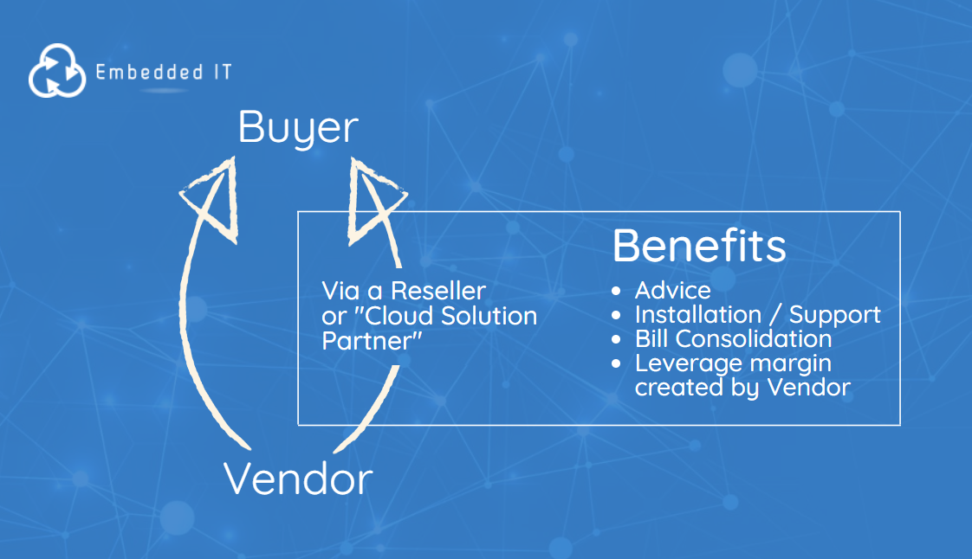

Author: Phil Clark

Phil Clark is the Treasurer of the CIPS South of England branch and actively supports CIPS events in the region to promote technology procurement with local students.

Phil is also the founder of the free Embedded Directory; a website designed to help technology buyers find the right technology suppliers. Over the past 25 years, Phil has overseen numerous senior commercial management roles within Client, Vendor and Service Provider organisations, and now focusses on supporting technology sourcing and procurement projects for UK clients.

The primary purpose of developing the Buying Guides is to collectively develop tools and resources that support the technology buying community. If you feel there were any questions missing from this checklist or have any information or guidance that should be included, please get in touch so that we can continually improve this free resource. All feedback is gratefully received.

For further commentary on technology supply chain and trends connect on LinkedIn.
Phil Clark
Embedded IT

Further Reading

If you found this useful, throughout 2020 Phil Clark and CIPS will be working on a series of IT Buying Guides for a range of Technology Projects which can be found here.

