CIPS Incoterms Guide
Incoterms Tools and Guidance Notes are essential for understanding and applying international trade rules. The Incoterms (International Commercial Terms), published by the International Chamber of Commerce (ICC), outline the responsibilities and risks of buyers and sellers in global transactions. They help outline the responsibilities and risks of buyers and sellers, clarifying who handles shipping, insurance, customs duties, and delivery.
Incoterms 2020 is the latest edition of the official Incoterms rules, published by the ICC. It provides a comprehensive set of terms used in international trade agreements. Organisations can benefit from ICC’s online tools and training courses designed to help integrate Incoterms into supply chain operations. Digital platforms and apps now make it easier than ever to ensure compliance and avoid costly misunderstandings in global trade.
The ICC typically reviews and revises Incoterms every 10 years, but the timing of updates is not fixed and depends on the pace of changes in international trade practices. While the current version, Incoterms 2020, remains in effect, an interim update could occur before 2030 if significant geopolitical events or rapid shifts in global trade warrant it.
Each term defines specific responsibilities for the buyer and seller regarding:
- Delivery locations (e.g., port, warehouse, etc.)
- Transport obligations
- Risk transfer
- Customs handling
- Cost allocation for transport, insurance, and duties

Incoterms Model
The model is a visual display of the different types of commonly used Incoterms. It shows the division of responsibilities between the supplier and the buyer for various tasks across different stages of the shipping process. The chart highlights who is responsible for specific actions under each Incoterm.
Each Incoterm has its unique division of responsibilities and risks, which this chart helps clarify.
Incoterm | Load  Ex Supplier | Transport | Insurance | Destination | Customs | Collection | Delivery | Final Destination
EXW | ✅ (Seller) | ❌ (Buyer) | ❌ (Buyer) | ❌ (Buyer) | ❌ (Buyer) | ❌ (Buyer) | ❌ (Buyer) | ❌ (Buyer)
FCA | ✅ (Seller) | ✅ (Buyer) | ❌ (Buyer) | ↔ (Buyer/Seller) | ❌ (Buyer) | ❌ (Buyer) | ❌ (Buyer) | ❌ (Buyer)
CPT | ✅ (Seller) | ✅ (Buyer) | ❌ (Buyer) | ↔ (Buyer/Seller) | ❌ (Buyer) | ❌ (Buyer) | ❌ (Buyer) | ❌ (Buyer)
CIP | ✅ (Seller) | ✅ (Buyer) | ✅ (Seller) | ↔ (Buyer/Seller) | ❌ (Buyer) | ❌ (Buyer) | ❌ (Buyer) | ❌ (Buyer)
DAP | ✅ (Seller) | ✅ (Seller) | ❌ (Buyer) | ✅ (Seller) | ❌ (Buyer) | ❌ (Buyer) | ✅ (Seller) | ❌ (Buyer)
DDP | ✅ (Seller) | ✅ (Seller) | ✅ (Seller) | ✅ (Seller) | ✅ (Seller) | ❌ (Buyer) | ✅ (Seller) | ✅ (Seller)
FAS | ✅ (Seller) | ✅ (Seller) | ❌ (Buyer) | ↔ (Buyer/Seller) | ❌ (Buyer) | ❌ (Buyer) | ❌ (Buyer) | ❌ (Buyer)
FOB | ✅ (Seller) | ✅ (Buyer) | ❌ (Buyer) | ✅ (Seller) | ❌ (Buyer) | ❌ (Buyer) | ✅ (Seller) | ❌ (Buyer)
CFR | ✅ (Seller) | ✅ (Seller) | ❌ (Buyer) | ✅ (Seller) | ❌ (Buyer) | ❌ (Buyer) | ✅ (Seller) | ❌ (Buyer)
CIF | ✅ (Seller) | ✅ (Seller) | ✅ (Seller) | ✅ (Seller) | ❌ (Buyer) | ❌ (Buyer) | ✅ (Seller) | ❌ (Buyer)

✅ (Seller): The seller is responsible for this part of the process.

❌ (Buyer): The buyer is responsible for this part of the process.

↔ (Buyer/Seller): Responsibility can vary based on what is agreed upon in the contract.

Example of Incoterms Application:
Let’s consider a scenario where a company in the U.S. (Buyer) is purchasing machinery from a supplier in Germany (Seller). The Incoterms used to define the responsibilities of both parties will vary based on the agreement.
Scenario 1: FOB (Free on Board)
- Load: The Seller in Germany is responsible for loading the machinery onto the ship.
- Transport: The Buyer in the U.S. will pay for transport from the port in Germany to the U.S.
- Insurance: The Buyer is responsible for insuring the goods during transport.
- Destination: The Seller handles delivery to the port in Germany.
- Customs: The Buyer manages customs duties in the U.S.
- Collection: The Buyer collects the goods after arrival in the U.S.
- Delivery: The Seller ensures delivery to the port in Germany, but the Buyer is responsible for further delivery after the shipment is loaded.
- Final Destination: The Buyer arranges for the final transport of the goods within the U.S.
Scenario 2: DDP (Delivered Duty Paid)
- Load: The Seller in Germany handles the loading of goods.
- Transport: The Seller covers all transport costs from Germany to the Buyer’s location in the U.S.
- Insurance: The Seller is responsible for insuring the goods during transport.
- Destination: The Seller handles all customs duties and processes for import into the U.S.
- Customs: The Seller manages all customs clearance procedures in the U.S.
- Collection: The Buyer does not need to handle collection since the goods are delivered directly to their location.
- Delivery: The Seller arranges the delivery to the final destination.
- Final Destination: The Seller takes care of all costs and responsibilities up to the Buyer’s final destination in the U.S.
In FOB, the Buyer has more responsibilities for transport, insurance, and customs, whereas in DDP, the Seller takes on nearly all responsibilities, including transport, insurance, customs, and final delivery.

Key Takeaways from an Incoterms Model:
- Risk Transfer: Understanding when the responsibility for the goods transfers from seller to buyer is crucial to avoid disputes over losses or damages.
- Cost Distribution: The model provides clear guidelines for dividing the costs, making it easier for both parties to agree on the terms of the contract.
- Clarity in Documentation: The model outlines the types of documents that each party is responsible for providing, ensuring a smooth transaction process.
- Using a structured Incoterms Model helps companies avoid misunderstandings, reduce risk, and improve the efficiency of their global trade processes.

Which Incoterm?
Here's a breakdown of the key Incoterms:
- EXW (Ex Works): If you want to have all the liability for the goods during the journey from the supplier to the end destination and are willing to manage all transportation and risks on your own.
- DDP (Delivered Duty Paid): If you want to have all liability but also prefer the supplier to handle all risks, including customs clearance, duties, and final delivery.
- CIP (Carriage and Insurance Paid To): If you want the supplier to be responsible for transporting and insuring the goods to a specified destination, but you are willing to take on the risk once the goods are handed over to the carrier.
- CPT (Carriage Paid To): If you want the supplier to cover the cost of transport to a destination of their choice but not insure the goods for the onward journey.
- FCA (Free Carrier): If you want to have control of the goods once they are handed over to a carrier, but the supplier handles the first part of the transportation.
- FOB (Free on Board): If you want the goods loaded onto the ship or aeroplane and cleared for export, you want to manage the onward freight and insurance.
- CIF (Cost, Insurance, and Freight): If you want the supplier to cover the cost, insurance, and freight to the destination port, including insurance for the onward journey.
- FAS (Free Alongside Ship): If you want the supplier to deliver the goods alongside the vessel, but you take responsibility once they are delivered to the port.
- DAT (Delivered at Terminal): If you want the supplier to deliver the goods to a terminal at the destination but are willing to take care of offloading and further transportation.
- DAP (Delivered at Place): If you want the supplier to handle delivery to a destination terminal, including all costs and risks, but you're still responsible for unloading.

The flowchart outlines decision-making steps to help choose the appropriate Incoterm for international trade based on a series of questions about liability, risk transfer, delivery responsibilities, and more.
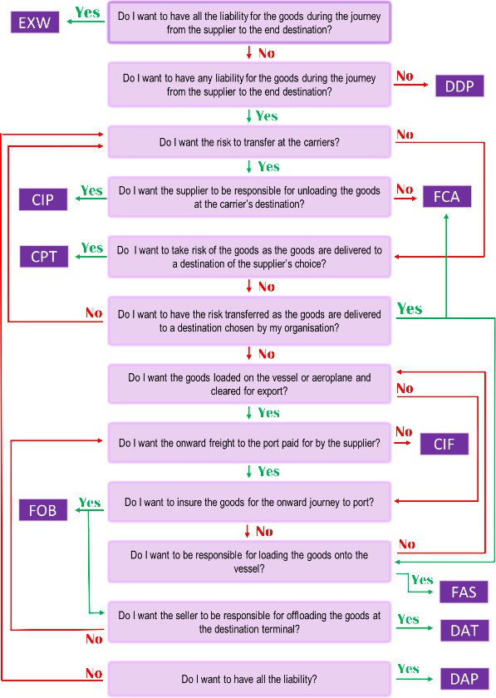
(Source: Jarvis-Grove, 2020)

